Akshat Guota Terraform setup and lab 1(on aws) akshu20791@gmail.com TERRAFORM SETUP

1) Install Visual studio code -> https://code.visualstudio.com/download

2) Go to terraform official website and download terraform for windows

https://www.terraform.io/downloads

3) Now open the zip and paste the exe file in C -> windows -> system32

(you can paste it anywhere but as per some company norms it should be in system32 folder)

4) Now search environment variables

And there click on environment variables button

In system variables -> double click on PATH

And paste the Terraform path there…. C:\Windows\System32\terraform

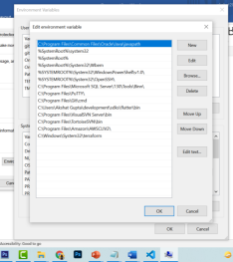

5) Now create a working folder…lets say project A

6) Now open visual studio code

File -> Open folder -> project A

Akshat Guota Terraform setup and lab 1(on aws) akshu20791@gmail.com

7) Now there on terminal -> New terminal

8) Now in that terminal check if terraform is properly installed or not .

For that put

➢ terraform -version

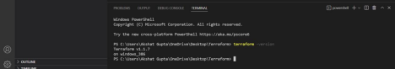**9) 1st method to configure AWS:**

Create IAM role with complete admin access

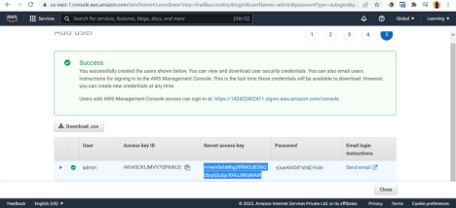

Search Aws terraform provider in google.com

Click https://registry.terraform.io/providers/hashicorp/aws/latest/docs

Now scroll down

provider "aws" {

region = "us-west-2"

access_key = "my-access-key"

secret_key = "my-secret-key"

Akshat Guota Terraform setup and lab 1(on aws) akshu20791@gmail.com }

In above replace region with us-east-1

Access_keys with the access key for iam user and secret key with secret key of iam user Image:

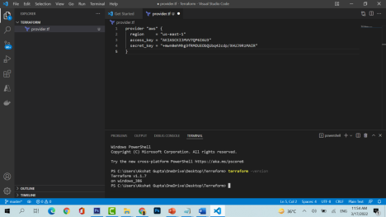10) To initiate terraform use “terraform init “ command in terminal

Akshat Guota Terraform setup and lab 1(on aws) akshu20791@gmail.com 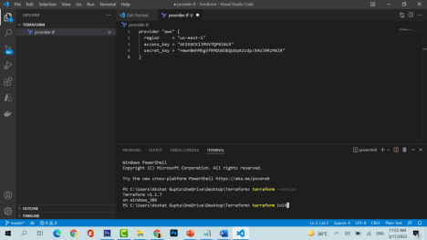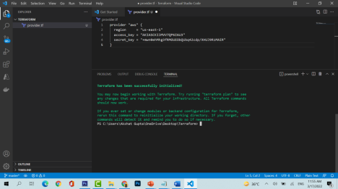It means our terraform is initialized successfully

2nd method to connect to AWS and terraform

Akshat Guota Terraform setup and lab 1(on aws) akshu20791@gmail.com

1) Search for AWS cli

2) https://awscli.amazonaws.com/AWSCLIV2.msi download the software from here 3) Install the software

4) now go restart your visual studio code

5) and then in terminal G

➢ aws configure

6) in terminal it will ask for access key and access secret key

Name: Akshat Gupta

Email: akshu20791@gmail.com